**SRI VENKATESHWARA GOVERNMENT POLYTECHNIC,TIRUPATI -517501**



**DEPARTMENT OF COMPUTER ENGINEERING**

**DOCUMENTATION OF SAMPLE TRY-OUT**

**(AP ECET MOCK TEST WEBSITE)**

**CERTIFICATE**

**INDEX OF SAMPLE TRY-OUT**

**CHAPTER NO DESCRIPTION PAGE NO**

**Abstract i**

1 Introduction

2 Project Description

3 Computational Environment

3.1 Software requirements

3.2 Hardware requirements

3.3 Operating environment

3.4 External Interface Requirements

3.5 Non-Functional Requirements

3.6 Software Features

4 Feasibility Study

4.1 Technical Feasibility

4.2 Operating Feasibilty

4.3 Economical Feasibility

5 System Analysis

5.1 Existing System

5.1.1 Drawbacks in Existing System

5.2 Proposed System

5.2.1 Advantages of proposed system

6 System Design

6.1 Data flow Diagrams

6.2 UML Diagrams

7 System Implementation

8 Testing

8.1 Unit Testing

8.2 Integration Testing

8.3 System Testing

8.4 Acceptance Testing

9 Sample Course Code

10 Screen Layouts

11 Conclusion and Future Enhanceme

ABSTRACT

### INTRODUCTION

### 

**3.3 operating environment**

In [computer software](https://en.wikipedia.org/wiki/Computer_software), an **operating environment** or **integrated applications environment** is the [environment](https://en.wikipedia.org/wiki/Deployment_environment) in which users run [application software](https://en.wikipedia.org/wiki/Application_software). The environment consists of a [user interface](https://en.wikipedia.org/wiki/User_interface) provided by an **applications manager** and usually an [application programming interface](https://en.wikipedia.org/wiki/Application_programming_interface) (API) to the applications manager.

An operating environment is *not* a full [operating system](https://en.wikipedia.org/wiki/Operating_system), but is a form of [middleware](https://en.wikipedia.org/wiki/Middleware) that rests between the OS and the application. For example, the first version of [Microsoft Windows](https://en.wikipedia.org/wiki/Microsoft_Windows), [Windows 1.0](https://en.wikipedia.org/wiki/Windows_1.0), was not a full operating system, but a [GUI](https://en.wikipedia.org/wiki/GUI) laid over DOS albeit with an API of its own. Similarly, the [IBM U2](https://en.wikipedia.org/wiki/IBM_U2) system operates on both [Unix](https://en.wikipedia.org/wiki/Unix)/[Linux](https://en.wikipedia.org/wiki/Linux) and [Windows NT](https://en.wikipedia.org/wiki/Windows_NT). Usually the user interface is [text-based](https://en.wikipedia.org/wiki/Text-based_user_interface) or [graphical](https://en.wikipedia.org/wiki/Graphical_user_interface), rather than a [command-line interface](https://en.wikipedia.org/wiki/Command-line_interface) (e.g., [DOS](https://en.wikipedia.org/wiki/DOS) or the [Unix shell](https://en.wikipedia.org/wiki/Unix_shell)), which is often the interface of the underlying operating system.

In the mid 1980s, [text-based](https://en.wikipedia.org/wiki/Text-based_user_interface) and [graphical](https://en.wikipedia.org/wiki/Graphical_user_interface) user interface operating environments surrounded [DOS](https://en.wikipedia.org/wiki/DOS) operating systems with a [shell](https://en.wikipedia.org/wiki/Shell_(computing)) that turned the user's [display](https://en.wikipedia.org/wiki/Computer_monitor) into a [menu](https://en.wikipedia.org/wiki/Menu_(computing))-oriented "[desktop](https://en.wikipedia.org/wiki/Desktop_metaphor)" for selecting and running [PC](https://en.wikipedia.org/wiki/IBM_PC_compatible) applications. These operating environment systems allow users much of the convenience of [integrated software](https://en.wikipedia.org/wiki/Integrated_software) without locking them into a single pack

**3.4 External Interface Requirements**:

These requirements include user interfaces (interaction logic between software and user), screen layouts, buttons, functions on every screen, hardware interfaces (here a team describes what devices the software is created for), and other relevant particularities.

**3.5 A Non-Functional Requirement**

**1. Reliability**

The system can update its content in real time. Therefore, changes such as addition, deletion or modification can be done immediately. This ensures that the content of the system is up-to-date, reliable and can be trusted. The system will also be able to produce all related output to queries.

**2.Availability**

The system can operate 24 hours per week and 365 days a year. As long as the user not shut down the desktop. All the information will be keep in the database. Even though, the desktop is shut off information still exist in the database.

**3. Security and Safety**

In order to avoid security and safety breach occur users need to login with username and password before they access the system. In database there have record the username and password. Only registered users can access the system and use it.

### 4.Maintainability

### The software is being developed by the web developing languages. Thus the system can be update in the coding part to maintain the system.

### 5. Portability

### The system is being developed using web programming language and MySQL. Before the system release to system needs to compile without any error before the system run. Therefore, the software will be able to run on any computer with web Browser and MySQL.

### 6. Performance

### The system performance is very fast. The processed transactions and event response time is quick. So user can do the transaction any event without feel stress on waiting.

### 7. Flexibility

### System is working easily on the Intranet with the username and password of the user. The system has given the rights to the lecturers and the students to use the system with their username. The system can also work on other kind of technology with the little modification. System should be quite flexible to install and maintain.

### 8. Efficiency

### System should be efficient enough to meet all kinds of requirements as required by the lecturers and students. The system should not hang or lose its efficiency in any kind of worse conditions. It should provide the correct output in all manners.

**9.User Friendliness**

System should be user friendly, so that any user can use and access the system with easiness.

**3.6 Software features**

**1. Automation Of Planning And Scheduling**

Online exam software should be capable enough to deal with the messy planning phase. It should be able to collect information from students via its online portal and set up a schedule, process student applications, generate automated admit cards, allot exams according to the subject, and mark attendance on responses.

**2. Assessment Pattern Creation**

Assessment pattern creation is more of a technical term used for setting up subject-wise question papers.

**3. Question Bank Management**

The question banks should be interactive in nature with proper multimedia support and text editors. The mode of presentation should be appealing, enough to draw the attention of individual students.

**4. Configuration Of Questions**

The software must be capable enough to help teachers set up multiple question patterns for any subject of their choice. Thus, including questions like multiple-choice, open-ended, quizzes, and more.

**5. Assessment Of Integrated Rubrics**

Rubrics are effective and efficient tools for assessing student performance.

**6. Easy Approval**

Online exam software must feature an automated assessment tool, making it easy for users to get the generated questions approved and corrected in a simultaneous manner.

**7. Multi-Language Support**

Say yes to the one which supports multiple languages, making it easy for you and your students

**8. Custom Test-Taking Options**

This process helps educators customize test-taking methods that are suitable for individual students

. **9. Configurable Roles And Permissions**

Online exam software should be able to provide proper access and set up verified roles, ensuring that individual admins and allotted teachers have full control.

**10. Online Proctoring**

Look for online exam software that provides proper methods of surveillance over individual students.

**11. Transcript Generation**

Online exam software should be able to provide transcripts via automated calculations.

**12. Automated Evaluation**

While going through papers submitted by individual students, teachers might be biased at times. Always look out for software involving various security stages, evaluator handling processes, and click-by-click audit mechanisms.

**Final Words**

Online Ecet mock test exam software is the future of academic assessments, providing various improvements over conventional methods with their automated systems and robust processing skills.

### 4. Feasibility study

#### 4.1. Technical Feasibility

Building online ECET MOC test is technically feasible. The hardware and software needed are all available, it not difficult to get them. Brief I can say the necessary resources needed for the development and maintenance of the system are available. Evaluated the availability of resources such as skilled personnel, equipment, materials, and financial resources to undertake and sustain the project. I am going to use html, java script, ajax, jquerry ,PHP and sql database.

#### 4.2. Operationally Feasibility

The project I am developing is operationally feasible as there is no need for users to have good knowledge in computer before using it. Evaluated the practicality, usability, and acceptance of the project by the users . I considered the user level of acceptance, willingness to adopt the new system, and potential resistance to change. The user can learn and use the system with easiness; he just needs to read the manual or tutorial from the developers.

#### 4.3. Economic Feasibility

Besides being technically feasible, developing this system is economically feasible as well. The development of the system does not require the developers to spend a lot of money. Assessed the costs involved in developing, implementing, and operating the project, including hardware, software, infrastructure, training, maintenance, and ongoing operational expenses The tools I will be using to develop the system are not expensive and the software’s are open source. All I need is time. Even the maintenance of the system will not be expensive. The system is indeed economically feasible.

**6 System Designs**

**6.1 Data Flow Diagrams**

DATA BASE

LOGIN PAGE

SIGN PAGE

LOGIN

SIGN IN

TEST

CONTACT

HOME

USER

FEED BACK

Registration Verification

TEST

Ready to test

Question Retrieving

from database

ECE TEST

EEE TEST

CSE TEST

answer evaluation

from database

RESULT

**6.2 UML Diagram**

**Registered verification**

**User**

Data Base

**user**

**Registration**

**New user**

**10 Sample Source Code :**

**10.1 Homepage Source code**

<!DOCTYPE html>

<html lang="en">

<head>

<meta charset="UTF-8">

<meta name="viewport" content="width=device-width, initial-scale=1.0">

<title>Mock Test Website</title>

<link rel="stylesheet" href="homepage.css">

</head>

<body>

<div class="header">

<div class="header_nav">

<img src="logo.jpeg" alt="">

<p>SAMPLE TRY-OUT</p>

</div>

<ul class="nav">

<li ><a href="HOMEPAGE.HTML">Home</a></li>

<li ><a href="sign_in_student.html">Tests</a></li>

<li ><a href="contact.html">Contact</a></li>

<li ><a href="login.html">login</a></li>

<li ><a href="sign_in_student.html">signup</a></li>

</ul></div>

<div class="content">

<h1>Welcome to ECET Mock Test Website</h1>

<p>Mock tests are arranged to give students a feel of the real exam. For most of the students about to take a major exam for the first time in their lives, mock tests provide a trial run. Being placed in the same situation and feeling the same amount of pressure before the actual competative exam will inculcate some self-analytical capacity and confidence in the student. Infact Mock Test helps in reducing pre-exam nervousness, as the candidate has already appeared for a version of the exam before, on the final day he will be more relaxed.</p>

<h2>"PRACTICE MAKES MAN PERFECT"</h2>

<button class="header__btn">

<a href="sign_in_student.html">LET'S PRACTICE</a>

</button> </div>

<section class="features">

<div class="container">

<h2 class="features__title">Features</h2>

<div class="features__grid">

<div class="features__item">

<img src="image2.png" alt="" id="flogo">

<h3 class="features__item-title">Expertly Written Questions</h3>

<p class="features__item-text">Our team of experts writes every question with care and precision to provide the most accurate and reliable results.</p>

</div>

<div class="features__item">

<img src="image1.png" alt="" id="flogo">

<h3 class="features__item-title">Realistic Testing Environment</h3>

<p class="features__item-text">Our timed tests simulate the real testing environment to help you feel comfortable and confident on test day.</p>

</div>

<div class="features__item">

<img src="image3.png" alt="" id="flogo">

<h3 class="features__item-title">Track Your Progress</h3>

<p class="features__item-text">Our detailed reports and analytics allow you to track your progress and identify areas where you need to improve.</p>

</div>

</div>

</div>

</section>

<section class="cta">

<div class="container">

<h2 class="cta__title">Ready to Get Started?</h2>

<p class="cta__subtitle">Sign up for free and start testing today!</p>

<a href="sign_in_student.html" class="cta__btn">Sign Up Now</a>

</div>

</section><footer class="footer">

<div class="container">

<p class="footer__text">&copy; 2023 Mock Test Website. All rights reserved.</p> </div>

</footer>

</body>

</html>

**10.2 Sign in page Source Code**

<!DOCTYPE html>

<html lang="en">

<head>

<title>Sign Up</title>

<link rel="stylesheet" href="style.css" />

<link

href="https://fonts.googleapis.com/css2?family=Roboto:wght@300&display=swap"

rel="stylesheet"/>

<style>

.lin{

width:80px;

height: 40px;

background-color:white;

box-shadow:10px white;

border-radius: 5px;

margin-left: 45%;

align:center;

}

</style>

<script src="https://ajax.googleapis.com/ajax/libs/jquery/3.6.0/jquery.min.js"></script>

<script>

$(document).ready(function()

{

$(".mn").click(function(){

$(".mn").css("border-color","black");

})

$(".mn1").click(function(){

$(".mn1").css("border-color","black");

})

$(".mn2").click(function(){

$(".mn2").css("border-color","black");

})

$(".mn3").click(function(){

$(".mn3").css("border-color","black");

})

$(".mn4").click(function(){

$(".mn4").css("border-color","black");

})

$(".mn5").click(function(){

$(".mn5").css("border-color","black");

})

$(".mn6").click(function(){

$(".mn6").css("border-color","black");

})

});

</script>

</head>

<body>

<div class="signup-box">

<h1>Sign Up</h1>

<h4>It's free and only takes a minute</h4>

<form name="myform" action="insert_student.php" method="post" >

<label>Name</label>

<input type="text" class="mn"placeholder="Enter Student name" name="name" required><br>

<label>student ID</label>

<input type="username" class="mn1" placeholder=" Enter your Diploma HallTicket Number" name="student_id" required>

<label>College Name</label>

<input type="text" class="mn2"placeholder="Enter your college name" name="college_name" required>

<label>Course</label>

<input type="text" class="mn3" placeholder=" Enter your department name" name="course" required>

<label>Email</label>

<input type="e-mail" class="mn4"placeholder="Enter your e-mail ID" name="e-mail" required>

<label>Username</label>

<input type="text" class="mn5"placeholder="Enter Username" name="username" required>

<label>Password</label>

<input type="password" class="mn6" placeholder="Enter 8 digit password" name="password" required><br><br><br>

<input type="submit" value="SUBMIT" />

</form><br><br><br>

<p class="aa">

By clicking the submit button,you agree to our <br />

<a href="terms_conditions.html" class="a">Terms and Condition</a>and<a href="terms_conditions.html" class="a">Privacy Policy</a>

</a></p>

<table><tr>

<td> <button class="lin"><a href="HOMEPAGE.HTML">HOME</a></button></td><td>&nbsp;&nbsp;&nbsp;&nbsp;&nbsp;&nbsp;&nbsp;&nbsp;

&nbsp;&nbsp;&nbsp;&nbsp;&nbsp;&nbsp;&nbsp;&nbsp;&nbsp;&nbsp;&nbsp;&nbsp;&nbsp;&nbsp;&nbsp;&nbsp;&nbsp;&nbsp;&nbsp;&nbsp;&nbsp;&nbsp;&nbsp;

&nbsp;&nbsp;&nbsp;&nbsp;&nbsp;&nbsp;&nbsp;&nbsp;&nbsp;&nbsp;&nbsp;&nbsp;&nbsp;&nbsp;&nbsp;</td>

<td><button class="lin"><a href="terms_conditions.html">NEXT</a></button></td></tr>

</table> </div>

<p class="para-2">

Already have an account? <a href="login.html">Login here</a>

<!--

</p class="para-3">

</body>

**</**html**>**

**10.3 Log in Page Source Code**

<!DOCTYPE html>

<html lang="en">

<head>

<title>Login </title>

<link rel="stylesheet" href="style.css" />

<link

href="https://fonts.googleapis.com/css2?family=Roboto:wght@300&display=swap"

rel="stylesheet />

<script src="https://ajax.googleapis.com/ajax/libs/jquery/3.6.0/jquery.min.js"></script>

<script>

$(document).ready(function()

{

$("#mn").click(function(){

$("#mn").css("border-color","black");

})

$("#mn1").click(function(){

$("#mn1").css("border-color","black");

})

$("#mn2").click(function(){

$("#mn2").css("border-color","black");

})

});

</script> </head>

<body>

<div class="login-box">

<h1>Login</h1>

<form action="login_action1.php" method="POST">

<label>STUDENT ID</label>

<input type="username" id="mn2" placeholder="Enter Diploma Hall Ticket Number" name="id" required>

<label>Email</label>

<input type="email" id="mn" placeholder="Enter Mail Id Ex:abc12@gmail.com " name="username" required>

<label>Password</label>

<input type="password" id="mn1" placeholder=" Enter 8 digit code " name="password" required><br><br>

<input type="submit" value="LOGIN" style="background-color:green;color:white;" />

</form>

<p> By clicking the submit button,you agree to our <br /><a href="terms_conditions.html">Terms and Condition</a> and <a href="terms_conditions.html">Privacy Policy</a>

</p>

</div>

<p class="para-2"> Not have an account? <a href="sign_in_student.html">Sign Up Here</a>

</p>

</body></html>

**11 Screen Layouts**

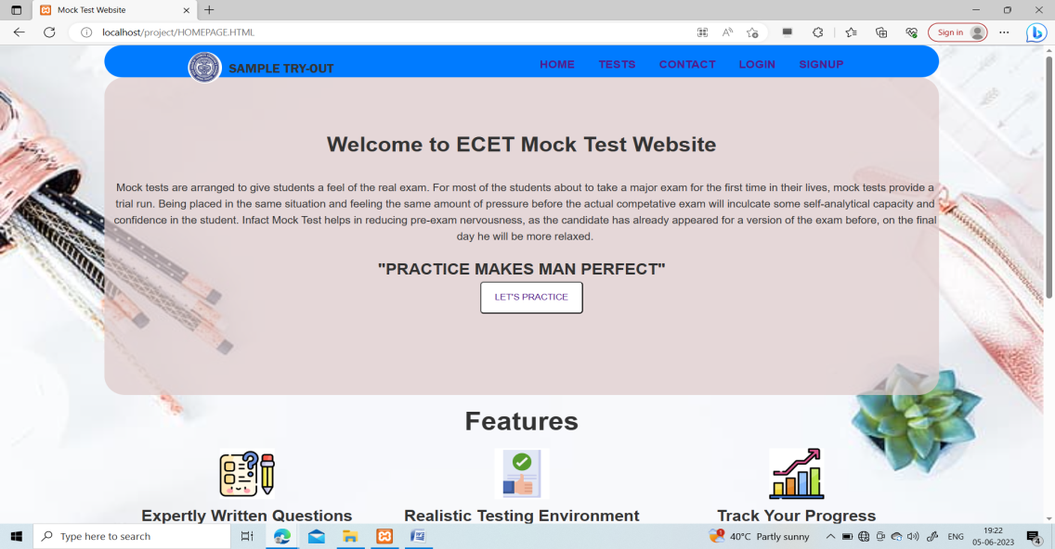

Homepage 1

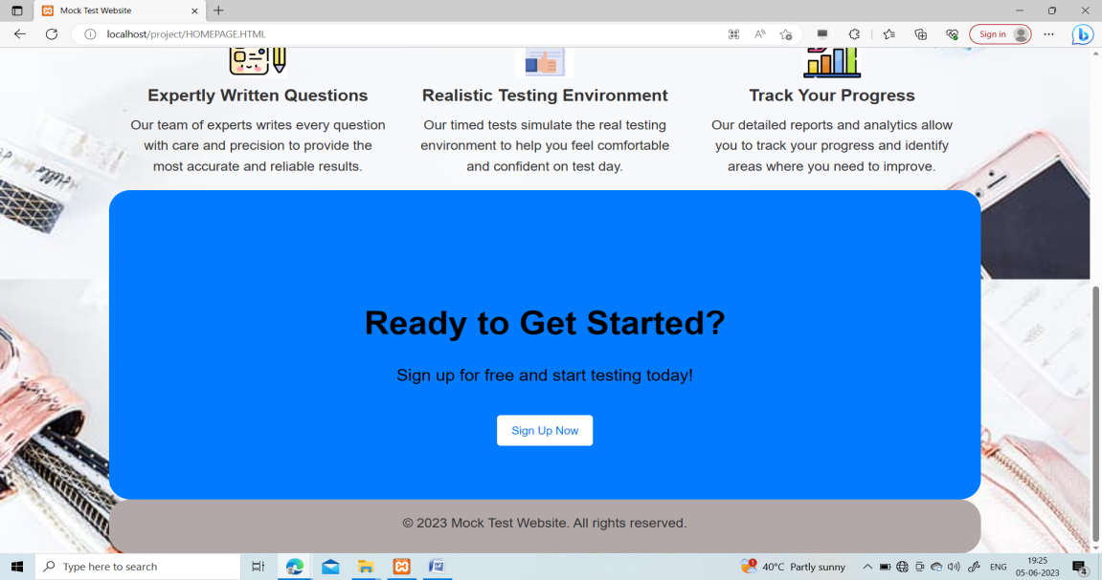

Homepage 1.1

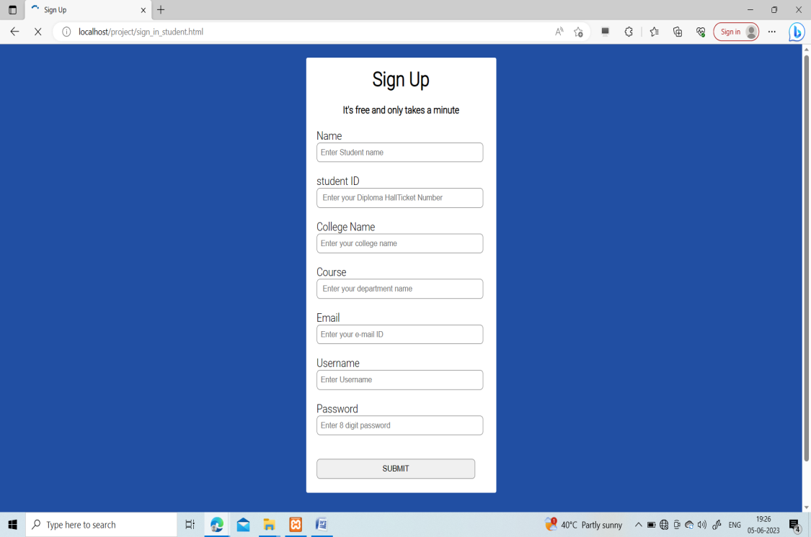

Sign in page

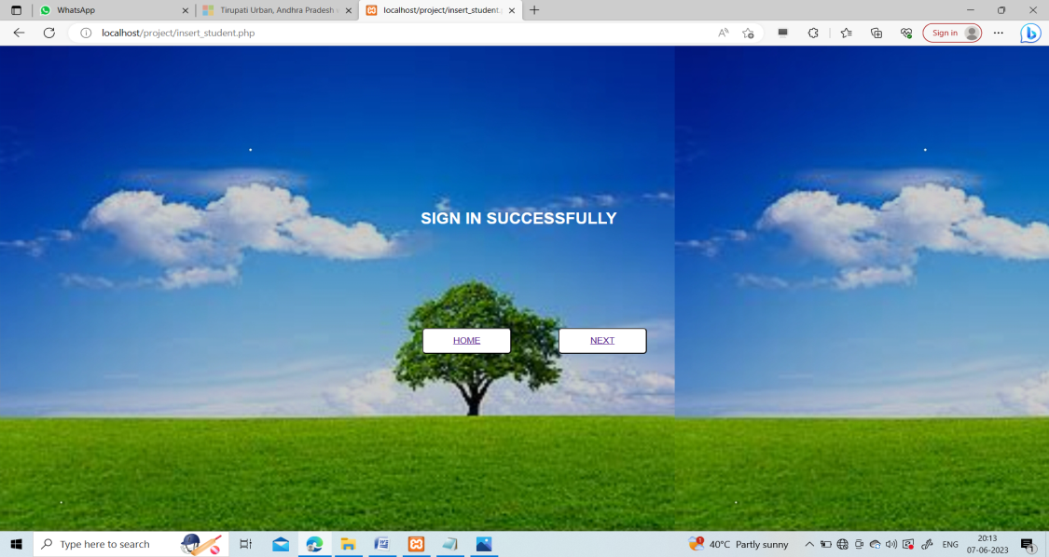

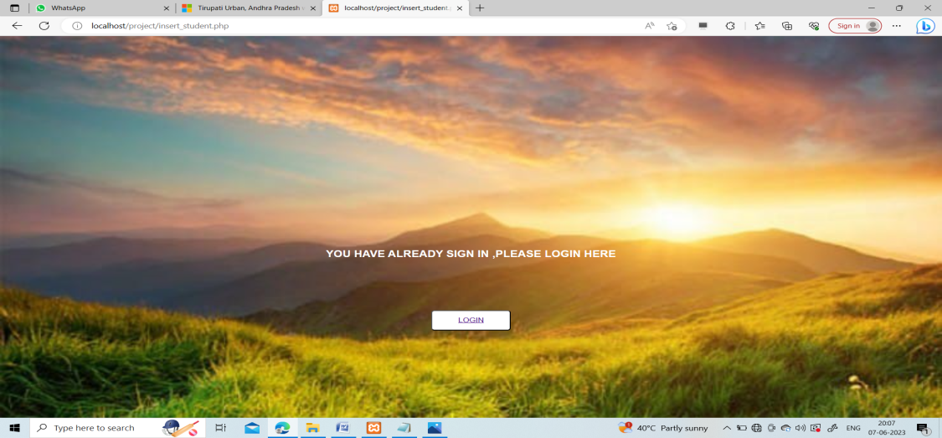

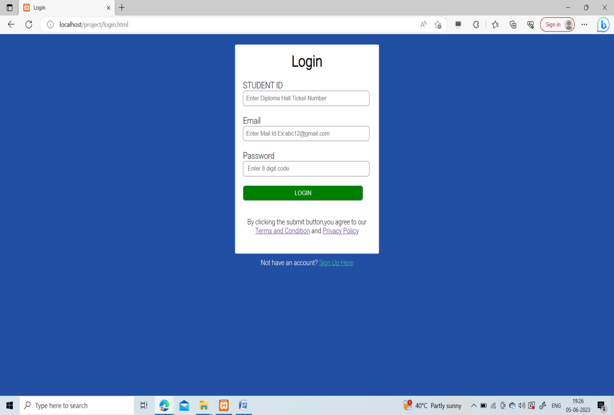

Log in Page

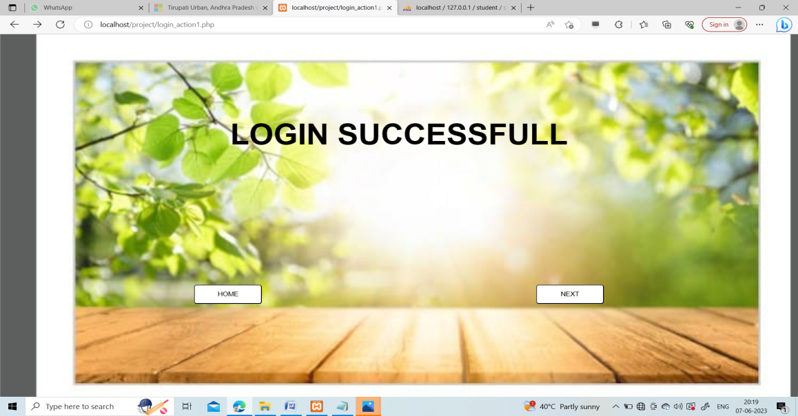

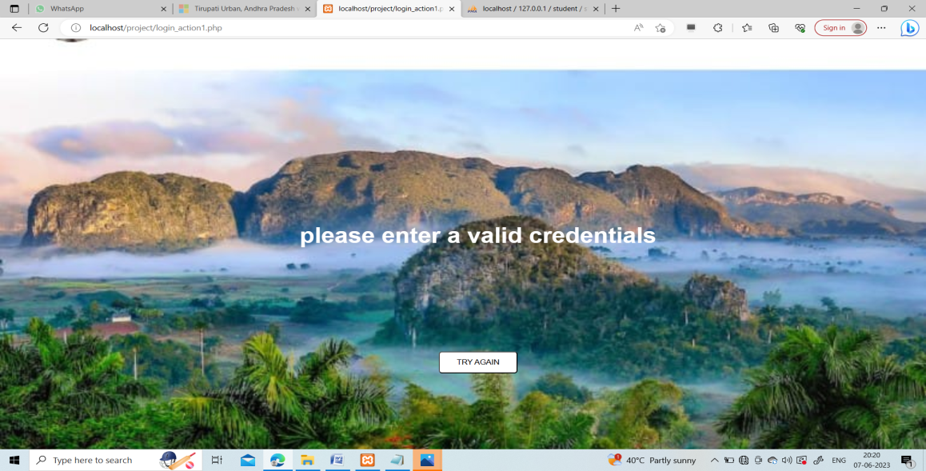

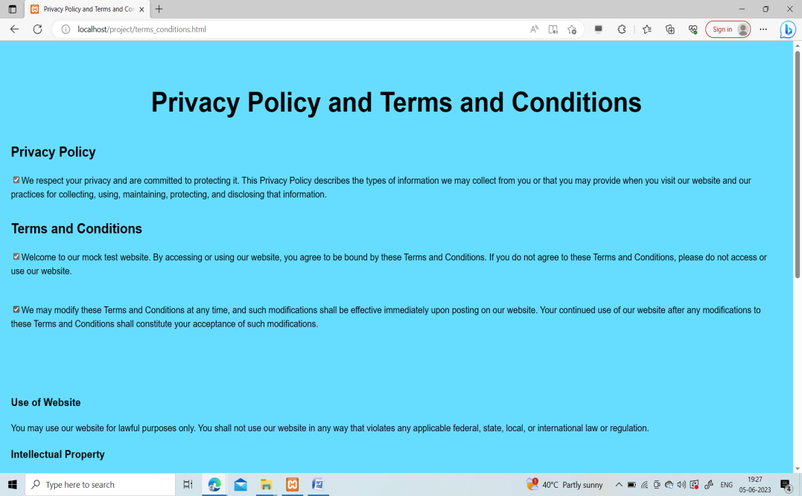

Privacy Policy and Terms And Conditions

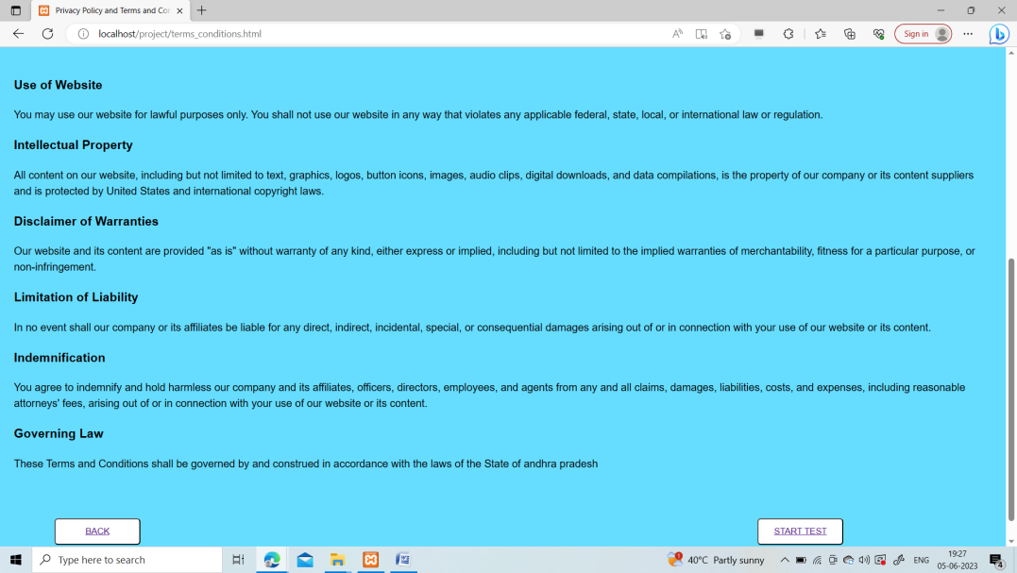

Privacy policy and Terms and Conditions 1.1

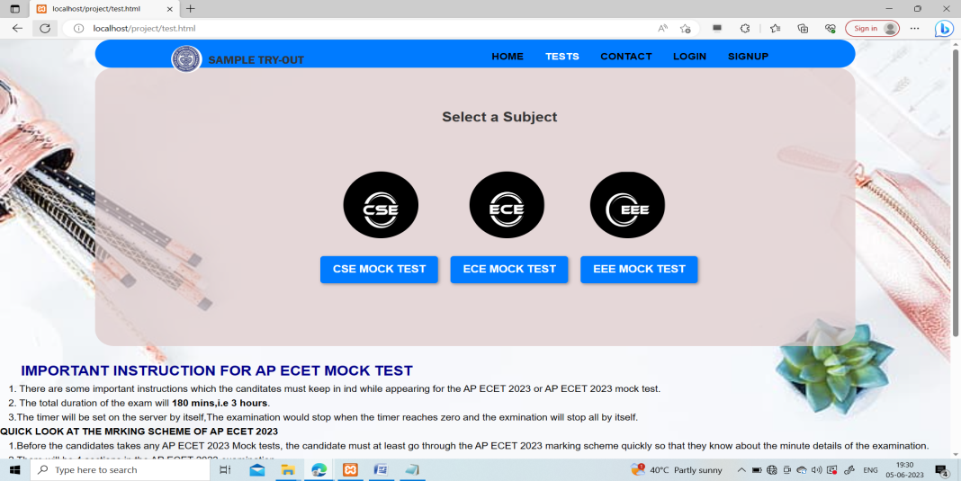

Test Access page 1

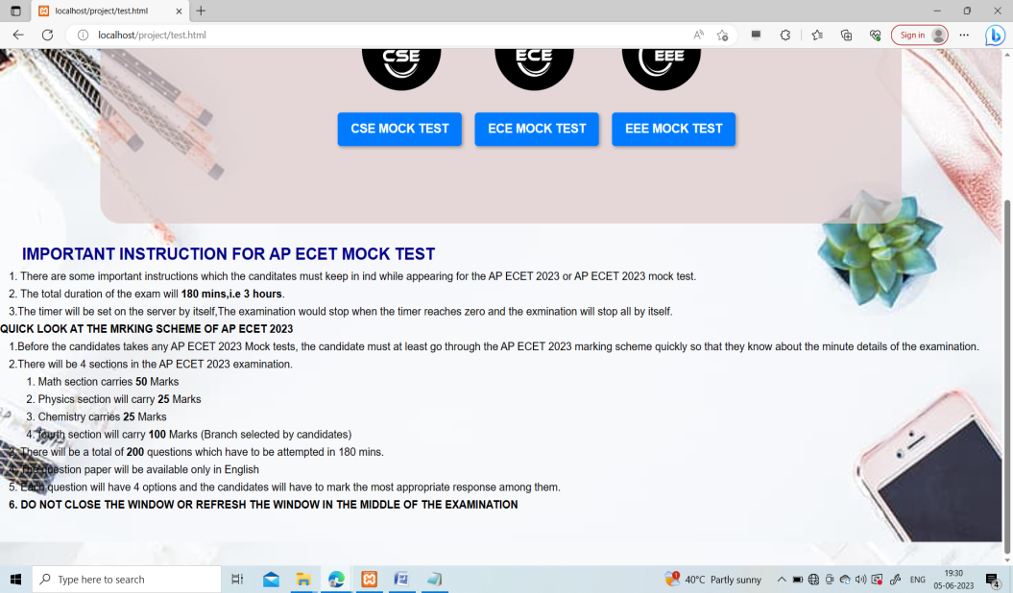

Test Access Page 1.1

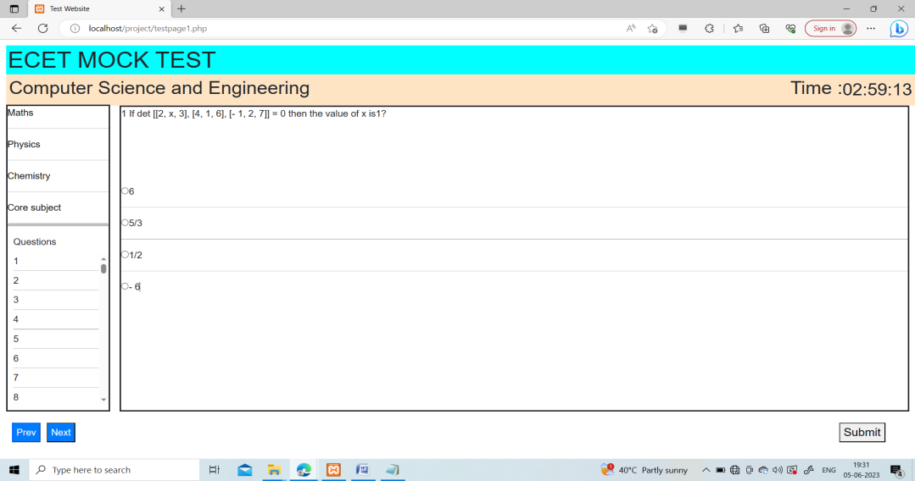

Test Page of Department of Computer Science and Engineering

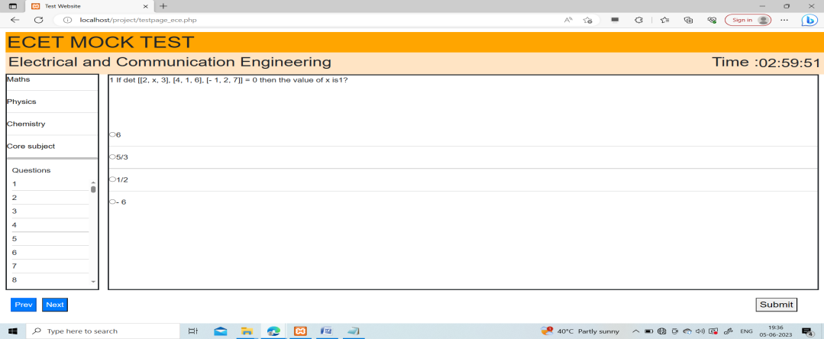

Test Page of Electrical and Communication Engineering

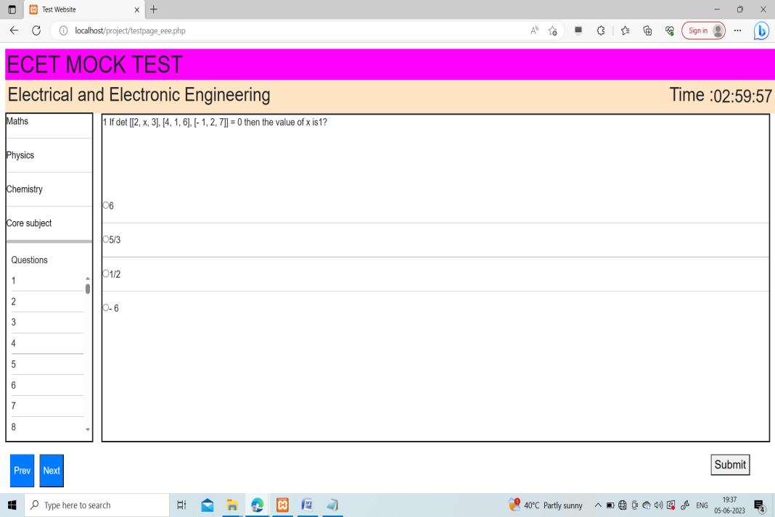

Test Page of Department of Electrical and Electronic Engineering

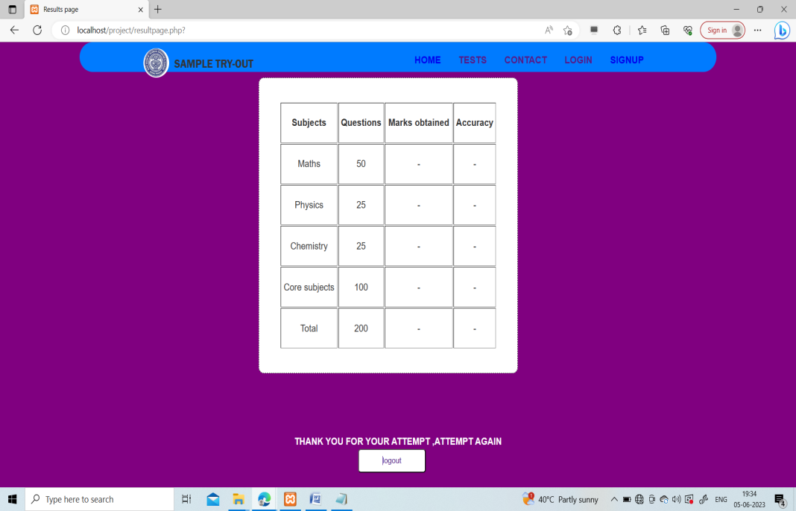

Result Page of all Test Pages

